Glen Eira City Council
Strategic Planning
PO Box 42,
Caulfield South VIC 3162

Dear Sir/Madam

Objection to Glen Eira Planning Scheme Amendment C143 & DDO Schedule 6
88-100 McKinnon Road, McKinnon

This letter lodges my objection to the above proposal. The grounds for this objection are as follows:

This proposed zone amendment is significant and detrimental to this area and it should not have been submitted to exhibition phase without community engagement, explanation and consultation.
The Design & Development Overlay proposes a 4 Storey Development in the middle of clearly defined residentially & neighbourhood zoned areas.

Mixed Use Zone inappropriate for site

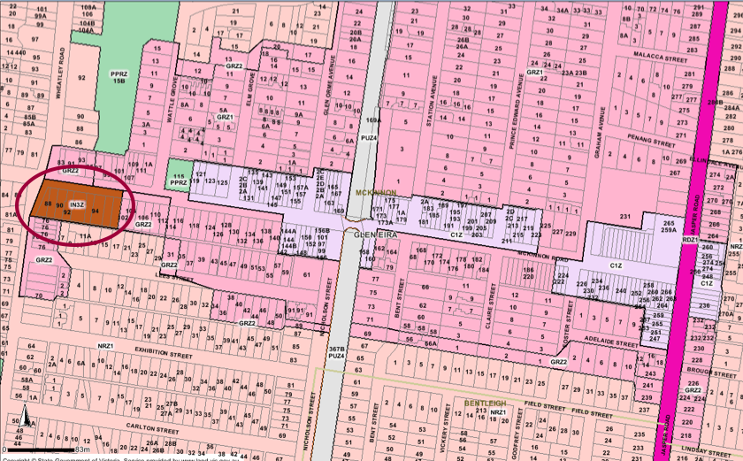

The Mixed Use Zone proposed is located within an area entirely residentially zoned of McKinnon Road.

As the above map shows, there is a clearly defined boundary between Commercial and Residential zones. All the land (including McKinnon Road itself) between Wheatley Road and Wattle Grove is classed as residential. The Park at Wattle Grove is also the point where the signpost advertising “McKinnon Village Shopping Centre” is located.

Council MSS – Clause 21:07-2 supports the rezoning to Residential: “Encourage the conversion of isolated pockets of industrially zoned land to residential where residential land use surrounds such sites”
Clause 21:07 – Zones & Overlays: zoning non-conforming industrial uses to match the predominant surrounding zone (in this case residential).

This site in question is not within the McKinnon Commercial Zone, it is in the middle of various types of residential zoned property.
(Page 23 of the Town Planning submission suggests that the site is nestled amongst residential and commercial zoned land and indeed the Glen Eira Planning Scheme Amendment Explanatory Report uses remarkably similar wording in its strategic assessment of the amendment “surrounded by residential & commercial uses”. This appears to form the basis for the proposed rezoning to Mixed Use.

The above map also shows that the site in question is very firmly located in a General Residential / Neighbourhood Residential Zone). It is adjoining the commercial zone – not “nestled within” – if this is used as a basis for re-zoning within a residential zone there would be no limits to how much “creep” could be introduced.

There is only one 4 storey development near McKinnon Station located in McKinnon Commercial Village of McKinnon Road (144a & 144b McKinnon Road). Others appear to be a maximum of 3 levels, including apartments along the railway line and at the corner of Lees Street.

Building 4 storeys due to flood plain.
Town Planning Application suggests that the reason to allow a 4 Storey Development is partially due to the site being located on a flood plain – this is the reality of the property location and not a reason to amendment to the Zoning heights which are very clearly set – and cannot exceed 3 storeys in a general residential zone. Suggesting that 4 storeys will make it a “gateway building” is totally out of size and character in the midst of a residential zoned area.

Appropriate Zone for proposed site
If it were rezoned to Neighbourhood Residential this would still provide option to develop with a range of housing options; however, at the moment in McKinnon there are very limited new housing options being provided – the current trend is for a large amount of high density apartments and removal of all existing “heritage” style properties.

Character
McKinnon is a village with an approx. land area of 2 sq. kms. The character of the suburb is being totally destroyed by large high density developments, and all the older style character properties are being bulldozed. If the site were re-zoned to Neighbourhood Residential, a more appropriate housing development style of 2 level townhouses would be in keeping with the character of this end of McKinnon Road. This would also add diversity to the housing options currently being offered on McKinnon Road providing an alternative housing style to the endless apartment blocks currently being erected.

Location in McKinnon Secondary School Zone.
Families are looking for housing options which provide SUITABLE housing for families (houses with space, backyards, children have room to play etc.) in the McKinnon Secondary School Zone.
Amendment C143 does not support this.

Neighbourhood Centres
The site is located within what is regarded as a “residential” area (see page 25 on Town Planning submission).
The Town Planning Report requests 4 storeys: This is out of policy/scope with the zoning at this end of McKinnon Road (which is General Residential (max 3 storey) – and neighbourhood (2 storey)

Increased traffic on street
MSS – Clause 21:08 (page 179)
Ensuring that traffic generated by a new use is appropriate to the location and can be accommodated within the existing street network
McKinnon Road is a Collection Road, not a major road. There is very limited on-street parking between Wattle Grove and Wheatley Road Roundabout (total 23 car parking spaces / mix of 2 hour and all day). Allowing a mixed zone development will cause traffic bottlenecks. The property is also located close to the Wheatley Road Roundabout (4 exit intersection, with 2 slip lanes). The entry/exit lanes are narrow – any large redevelopment will add traffic congestion and increased difficulty for residents parking in neighbouring residential streets.

There are also two junior schools (pre-school and a primary school) located on Wheatley Road close to the roundabout intersection with McKinnon Road – traffic congestion at school hours already reduces Wheatley Road to a single lane; redevelopment will add to this problem and also increase danger level for children (the Industrial businesses currently located in the proposed redevelopment site have their own on site parking at present).

Other issues with Mixed Use Zone
Businesses allowed in a Mixed Use Zone (coffee shops / bottle shops / take-away / mini-marts / newsagents which operate outside the hours of operation currently in the Industrial Zone, and which cannot operate in a residential zone without a permit), will compromise the surrounding residents’ right to quiet enjoyment on their premises. The industrial buildings currently located on the site work on very set hours, and reduced hours on week-ends, so have minimum impact.

Other issues include:
- delivery issues for suppliers and parking
- Waste management issues
- increased noise
- water runoff after rain
- Increased number of people loitering near my property creating safety/security concerns.

Personal
Rezoning and inappropriate development of site 88-100 McKinnon Road not only affects McKinnon, but the Glen Eira electorate as a whole. This development proposal does not take into consideration nearby dwellings, surrounding residential zones, road safety, road congestion, the right to be secure, and the right to privacy and quiet enjoyment. Ultimately this will destroy the overall character of McKinnon sets a dangerous precedent for unsafe neighbourhoods.

Yours sincerely

………………………………………. ……………………………………………….
Signature No. and Street Name

………………………………………. ……………………………………………….
Name – please print Suburb and Postcode

……………………………………………………… ……………………………………………….
Date Telephone

